1. Open your circuit schematic
2. Create Net Labels for any desired Connections
   1. You will need to set port types to Input, Output, or Bi-Direct.

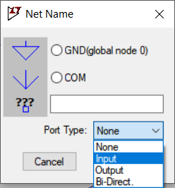

1. Under the Hierarchy tab click on “Open this Sheet’s Symbol”

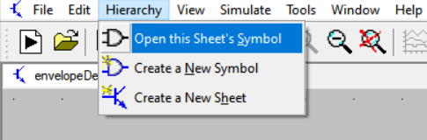

1. Create a symbol with the tools under the draw tab
   1. If you’d like, you can look at envelopeDetector.asy or 4p_BP_Filter.asy for reference but fancy drawing like they have are not required
   2. If you accidentally delete a pin, you can add them back under the Edit tab -> Add pin/port (just make sure the label is the exact same as is on your schematic, though it doesn’t need to be visible)

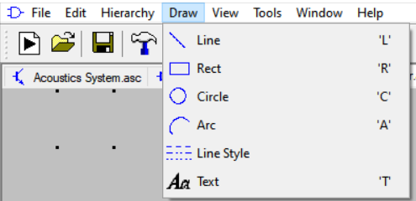

1. Under Hierarchy, “Open Schematic” and “Open this Sheet’s Symbol” should loop between symbol and schematic
2. Keep everything in the LTSpice folder otherwise references break
3. When adding your symbol to the top level (Acoustics System.asc) schematic, you’ll need to change your Top Directory at the top

